Identifying the different types of disability and situational challenges
Categories of persona and disability | Visual   | Auditory   | Mobility   | Cognitive  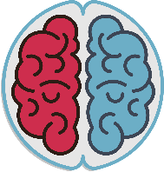
Permanent disability
Temporary disability
Situational barriers

